**Melonoma cancer detection using Machine Learning**

**Abstract :**

In humans, skin cancer is the most common and severe type of cancer. Melanoma is a deadly type of skin cancer. If it identifies early stages, it can be easily cured. The formal method for diagnosing melanoma detection is the biopsy method. This method can be a very painful one and a time-consuming process. Our project gives a computer-aided detection system for the early identification of melanoma. In this study, image processing techniques and the Support vector machine (SVM) algorithms are used to introduce an efficient diagnosing system. The affected skin image is taken, and it sent under several pre-processing techniques for getting the enhanced image and smoothed image. Then the image is sent through the segmentation process using morphological and thresholding methods. Some essential texture, color and shape features of the skin images are extracted. Gray Level Co-occurrence Matrix (GLCM) methodology is used for extracting texture features. These extracted GLCM, color and shape features are given as input to the SVM classifier. It classifies the given image into malignant melanoma or benign melanoma. High accuracy of 83% is achieved when we combine and apply the shape, color and GLCM features to the classifier.

**Literature Survey** :

* The proposed system the dermoscopy images were preprocessed by hair removal, glare removal and shading removal process. Segmentation method and watershed methods were used for the segmentation purpose. Color, shape, size and texture features are extracted and the SVM and CNN are used for the classification purpose.
* The diagnosing methodology is based on Support Vector Machine (SVM) algorithm for the classification purpose. In order to remove unwanted noise, the median filter is used. and the contrast enhancement is used for the purpose of getting better quality image results. Then the segmentation is done by using maximum entropy thresholding. Only GLCM methodology is used for texture image analysis for feature extraction.
* The Grab Cut algorithm used for the segmentation, and features are extracted by using ABCDE rule (ABCDE rule: Asymmetry, Border irregularity, Color, Diameter and Evolving size). These extracted features are categorized as cancerous or non-cancerous mole by using SVM. This paper conducted evaluation experiments with 200 images (100 of melanoma and 100 of benign).

**Introduction** :

* Melanoma, the most serious type of skin cancer, develops in the cells (melanocytes) that produce melanin — the pigment that gives your skin its color. Melanoma can also form in your eyes and, rarely, inside your body, such as in your nose or throat.
* The exact cause of all melanomas isn't clear, but exposure to ultraviolet (UV) radiation from sunlight or tanning lamps and beds increases your risk of developing melanoma. Limiting your exposure to UV radiation can help reduce your risk of melanoma.

**Symptoms**:

* Melanomas can develop anywhere on your body. They most often develop in areas that have had exposure to the sun, such as your back, legs, arms and face.
* Melanomas can also occur in areas that don't receive much sun exposure, such as the soles of your feet, palms of your hands and fingernail beds. These hidden melanomas are more common in people with darker skin.
* The first melanoma signs and symptoms often are:
* A change in an existing mole
* The development of a new pigmented or unusual-looking growth on your skin
* Melanoma doesn't always begin as a mole. It can also occur on otherwise normal-appearing skin

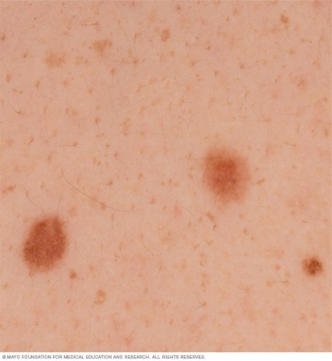

**Moles**

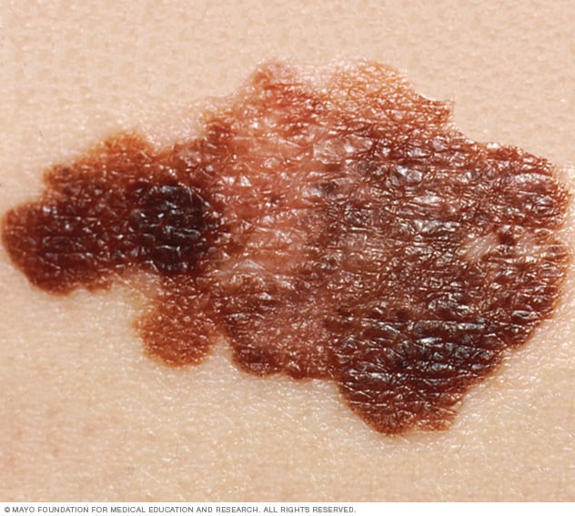

**Melanoma**

**Hidden Melanomas**:

Melanomas can also develop in areas of your body that have little or no exposure to the sun, such as the spaces between your toes and on your palms, soles, scalp or genitals. These are sometimes referred to as hidden melanomas because they occur in places most people wouldn't think to check. When melanoma occurs in people with darker skin, it's more likely to occur in a hidden area.

Hidden melanomas include:

* **Melanoma under a nail.** Acral-lentiginous melanoma is a rare form of melanoma that can occur under a fingernail or toenail. It can also be found on the palms of the hands or the soles of the feet. It's more common in people of Asian descent, black people and in others with dark skin pigment.
* **Melanoma in the mouth, digestive tract, urinary tract or vagina.** Mucosal melanoma develops in the mucous membrane that lines the nose, mouth, esophagus, anus, urinary tract and vagina. Mucosal melanomas are especially difficult to detect because they can easily be mistaken for other far more common conditions.
* **Melanoma in the eye.** Eye melanoma, also called ocular melanoma, most often occurs in the uvea — the layer beneath the white of the eye (sclera). An eye melanoma may cause vision changes and may be diagnosed during an eye exam.

**Methods which are already existing – Architecture Structure:**

* In this article they have used encoder and decoder architecture to remove the hair in dermoscopic images.
* They used pair of images that are formed by reference images and without hair which used only when computing the loss function and corresponding image with simulated hair.
* Here the encoder is used to remove the high-level features from the image where comes to decoder is used to recover the missing feature from the high level .
* In this encoder-decoder model the encoder is used to remove the artifact's like hair because the hair becomes noise that can be ignored by encoder.

**Reconstruction loss function:**

**This method measures how well the decoder is performing**, i.e. measures the difference between the encoded and decoded vectors **and how close the output is to the original input.**

**Drawbacks:**

* Here only some parts of skin lesions are taken into consideration.
* Only limited datasets are used .
* Takes longer time
* Less efficient
* When the data is small , algorithms doesn’t perform that well.
* Melanoma Skin cancer is not detected.

**Proposed Method:**

* **Machine Learning** can be used for detection of Melanoma Skin cancer using **Image processing.**
* **Image Pre-processing :** Improvement of quality of the image is main cause of it.

**Steps to Pre-process the image:**

* Noise and Hair removal : Removing noise and unwanted hair from the image is main purpose of this process.
* Conversion of RGB to Gray Scale : The Grayscale conversion change color images into gray scale because grayscale images are easier and faster to process than colored images.
* Smoothing the image using Gaussian filter : Blurring of image
* Segmentation
* Feature extraction

**Improvements:**

* Multiple data sets are used.
* Melanoma skin cancer is depicted.
* Improved efficiency
* Time conserving
* Gives accurate result with small amount of data